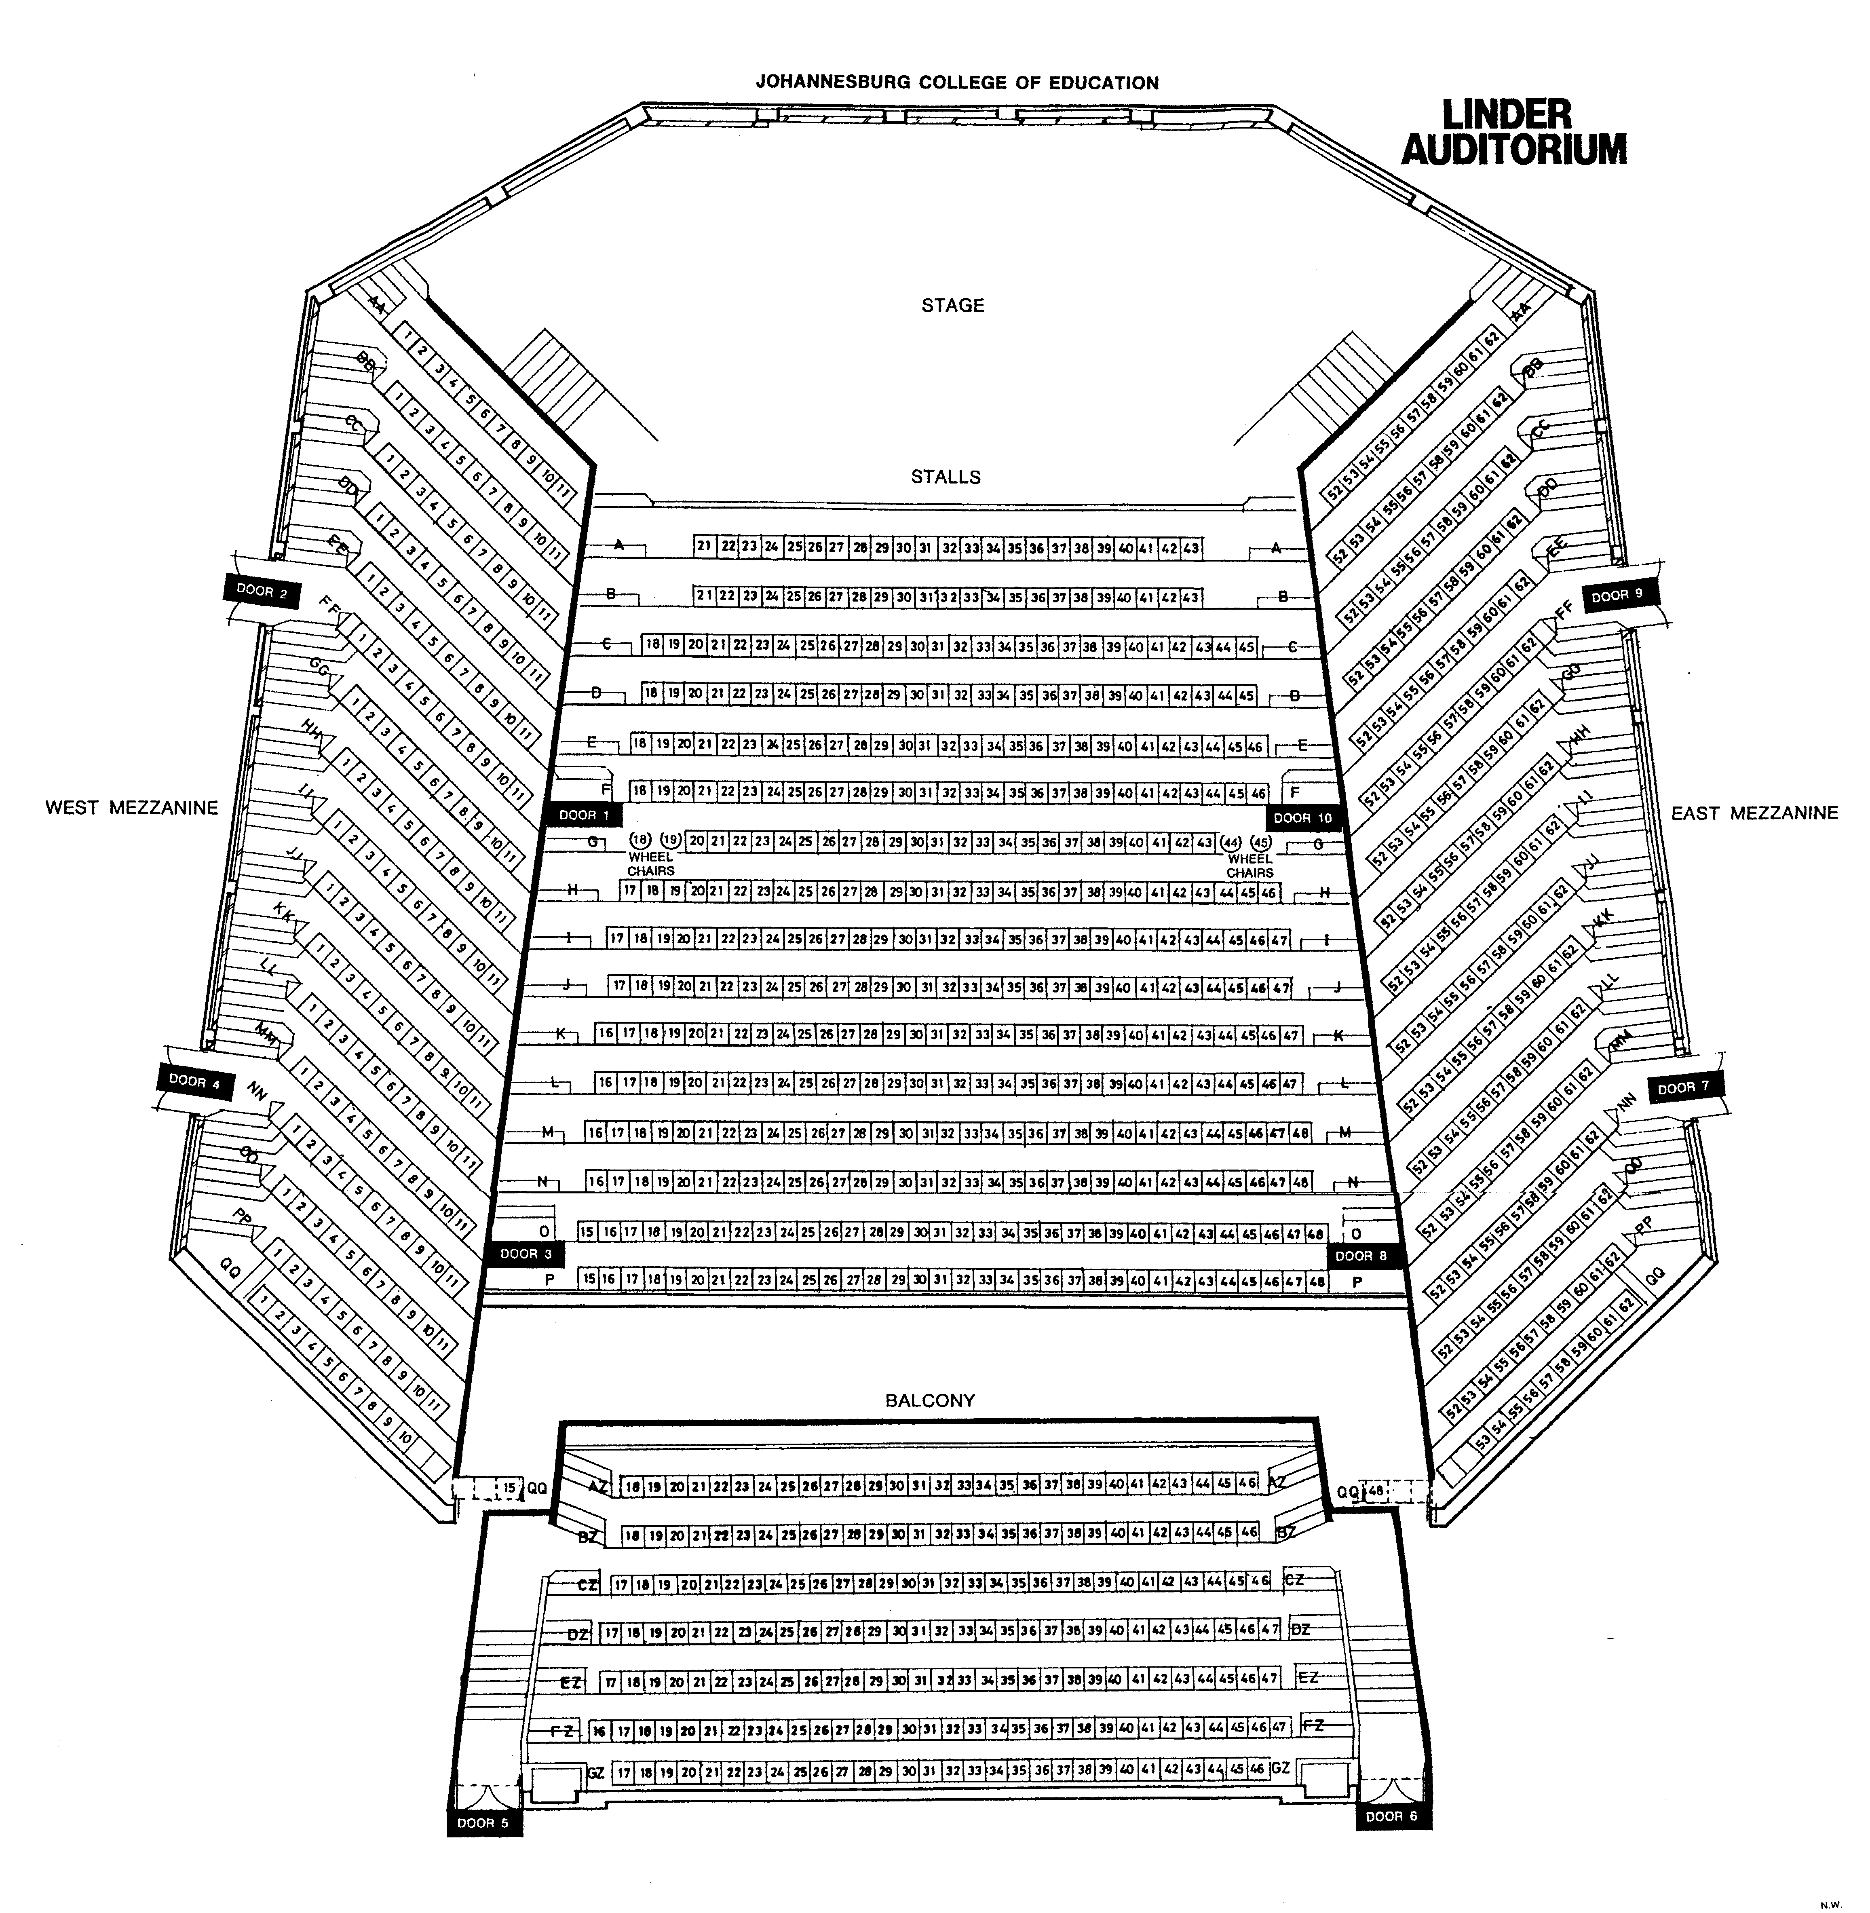
Seats 1059
9 m
Seats 474
16 m
Seats 186
Seats 186
Seats 213

