Price setting in South Africa 2001 to 2007 – Stylised facts using consumer price micro data
kenneth creamer* and neil rankin**

Abstract

Inflation, a macroeconomic variable, is underpinned by microeconomic data. This paper uses a large microdata sample at the unit level of South Africa’s Consumer Price Index (CPI) for the period 2001m12 to 2007m12 to begin to understand price setting conduct in South Africa. An understanding of price setting conduct is important since macroeconomic models, used for monetary policy, often incorporate estimates of pricing conduct. Often these estimates are not based on rigorous analysis of the underlying data. The dataset used in this paper allows for the following to be calculated: the frequency of price changes, the frequency of price increases and price decreases, findings on the magnitude of price changes, price increases and price decreases, and findings on the duration of prices, and thus provides a more accurate estimate on pricing conduct than has been previously available for South Africa. Results are presented at both an aggregate and a disaggregated level, based on the CPI’s major product categories and show the heterogeneous nature of price changes within the South African economy. These South African results are compared briefly to the results for other countries, where such micro level price data analysis has been undertaken. The study is part of a broader research effort into the implications of price setting conduct for monetary policy in South Africa, including an analysis of time- and state-dependent factors influencing the frequency and magnitude of price changes.

Introduction

Inflation, mostly thought of as a macroeconomic variable, is underpinned by microeconomic data. The overall inflation rate is an aggregate measure of changes in prices at the unit level. The analysis of unit level CPI microdata facilitates an understanding of actual price setting conduct at the most basic level. This is important, since imperfect pricing conduct, or price rigidity, is incorporated into macroeconomic models that are used to guide monetary and other types of policies that have real effects. It also matters because aggregate inflation rates may disguise different underlying patterns of price changes which policy makers may be concerned about. For example, an inflation rate of 5% may mean that all prices always change by 5%, or that half the prices change by 10%. Policy makers may care about the pattern of price changes if they affect certain groups, such as poor households, more than other groups.
This paper finds considerable heterogeneity of pricing conduct in South Africa during the period 2001m12 to 2007m12 both in terms of changes in pricing conduct over time and variations in pricing conduct across product categories. There is also evidence of pricing asymmetry as, across all product categories over the period, prices were more likely to rise than they were likely to fall. In absolute value terms, the magnitude of price decreases is larger than the magnitude of price increases, although price decreases occur less frequently than price increases. Variations in the magnitude of price changes are less pronounced over time than frequency variations, but there is considerable heterogeneity in the magnitude of price changes (both increases and decreases) across various product categories.
The structure of the paper is as follows: a brief indication of the importance of assumptions or estimates regarding pricing conduct in macroeconomic models of the optimal conduct of monetary policy; an overview of the data issues associated with using the unit level CPI data set; an outline of the findings on the frequency of price changes; an outline of the findings on the magnitude of price changes; a discussion on the duration of prices; a brief outline of comparative analyses using price data studies from other countries; a discussion of possible extensions to the current microdata study; and a conclusion.

Pricing conduct and macroeconomic theory

New Keynesian models incorporate price rigidity in order to explain why monetary policy is non-neutral and impacts on short- and medium-term output and employment levels (see Gali 2008 for a recent exposition of this theoretical framework). As such, an improved understanding of pricing conduct and price rigidities improves the understanding of the manner in which monetary policy decisions impact on real economic outcomes.
An example of a model of this type is developed by Altissimo et al., (2006) and assists in the analysis of monetary policy in the context of varying degrees of price rigidity. The model comprises a Phillips Curve, an IS curve and a Taylor rule, as follows:

Where: π = inflation, y = the output gap, E = expectations operator, µ = a cost push shock, ε = a demand shock, r = the policy interest rate, κ = the degree of response of inflation to output, σ = variance of cost push shocks, λ = extent of interest rate smoothing by authorities, and γ = proportion of backward looking or price-indexing firms

The model responds to a cost-push shock µ as follows: an increase in prices due to μ leads to an increase in inflation π (Phillips Curve relation); the increase in π leads to an increase in the policy interest rate r (Taylor rule); this leads to a restraining of output growth y (IS curve); which ultimately leads to reduced pricing and containment of inflation (Phillips curve).
Stickier prices, that is, prices of lower change frequency or longer durations, are associated with smaller κ values. The model has different outcomes depending on whether the degree of price stickiness in the economy is low (short price duration and larger κ values) or high (long price duration and smaller κ values). The optimal response to a cost shock is dependent on the degree of price stickiness resulting in different paths for output, inflation and the nominal and real interest rates.
For example, if prices are of a relatively long duration then the increase in nominal and real interest rates required to keep inflation in check is less than would be required if price durations were relatively short. This is due the fact that with small κ values (sticky prices) the impact of the cost shock µ will result in lower levels of inflation and hence will require less of an interest rate response and less of a sacrifice of output in order to return medium term inflation to its target range.

Data issues

This paper uses a large microdata sample at the unit level of South Africa’s Consumer Price Index (CPI) for the period 2001m12 to 2007m12 to begin to understand price stickiness in South Africa. The data allows for findings to be made for the sample on the following issues: the frequency of price changes, the frequency of price increases and the frequency of price decreases, findings on the magnitude of price changes, the magnitude of price increases and the magnitude of price decreases, and findings on the duration of price spells. Results are presented at both an aggregate and a disaggregated level based on the CPI’s major product categories.
The study follows on from equivalent studies of CPI microdata that have been undertaken for a number of economies including the United States (Bils et al., 2004 and Klenow et al., 2005), Israel (Baharad et al., 2003), Spain (Alvarez et al., 2004), France (Baudry et al., 2004), the Euro Area (Alvarez et al., 2005), Portugal (Dias et al., 2005), Sierra Leone (Kovanen 2006), Brazil (Gouvea 2007) and Slovakia (Coricelli and Horvath 2008). Such studies are of considerable interest in showing the benefits that access to official data can have for both academic and policy research.
The current study is based on the large data sets at unit level of South Africa’s CPI data. This comprises 3 930 977 price records gathered over a 73 month period from 2001m12 to 2007m12.
In terms of this approach, each individual price record corresponds to a precisely defined item sold in a particular outlet at given point in time, therefore the pricing of individual items can be followed over time within the same outlet. Along with each individual price record the following additional information is provided: the year and month of the record; the item code (indicating the type of product), a unit code (indicating the specific variety of the product), a capture code (indicating the capture status of the item), and a numeric outlet code (which in terms of relevant legal confidentiality requirements does not enable the name of the outlet to be identified, but which enables the tracking of pricing activity at specific anonymous outlets). Furthermore, a complementary data-set was integrated into the main data-set which enabled the identification of whether specific items where classified as goods or services.
Due to the fact that the price collection methodology of Statistics South African changed from a fax-based approach to one of direct price collection by enumerators over the period and related systems changes, there is a break in the data at 2006m3. The reason for this break is that there is no equivalence in the numeric outlet codes for the two price collection systems so it is not possible to compare price changes at store level during the first month of the new collection methodology. Fortunately, this does not prevent comparable analysis of the frequency and magnitude of price changes at aggregated and disaggregated levels for the other months included in the study. One noteworthy implication of the break in the data which will be discussed is that it impacts on the analysis of the duration of prices, biasing price duration downwards.
The unit level data for the first period, 2001m12 to 2006m2, comprised 3 710 573 price records. For the second period, 2006m3 to 2007m12, there were 1 221 333 price records. From this total of nearly 5 million price records, 3 930 977 price records were included in the study based on the following criteria:
- Only data which was recorded with an acceptable capture status was included.
- Only data which was collected at a monthly frequency was included.
There are 1 124 goods and services in the CPI basket. The CPI basket is further divided into 18 categories. The dataset of monthly price data used in this study comprises the breakdown by product category outlined in Table 1, in which there are effectively 16 categories, as housing and education price data are excluded. Accordingly, price data are included for product categories which constitute a total weighting of 84,8% of the products included in the CPIX and 74,3% of the products included in the CPI.
As indicated by Table 1, even though the same basic price data is used to construct the various published inflation indices, there are important differences between the sample data set and the constructed indices. There is not a one-to-one mapping between the price data sample and proportion of product sub-categories in the Consumer Price Index (CPI) for historical metropolitan areas and Consumer Price Index excluding interest rates on mortgage bonds (CPIX) for historical metropolitan and other urban areas.

Table 1. Price records by product category
 | Number of Price records | % of total | Weighting in CPIX | Weighting in CPI
FOOD | 1769419 | 45 | 25.7 | 21
NON ALCOHOLIC BEVERAGES | 80980 | 2.1 | 1.3 | 1.1
ALCOHOLIC BEVERAGES | 143971 | 3.7 | 1.7 | 1.4
CIGARETTES TOBACCO AND CIGARS | 60538 | 1.5 | 1.4 | 1.1
CLOTHING | 250243 | 6.4 | 2.5 | 2
FOOTWEAR | 91283 | 2.3 | 1.5 | 1.2
HOUSING | 0 | 0 | 11.6 | 22.1
FUEL AND POWER | 16796 | 0.4 | 4.3 | 3.5
FURNITURE AND EQUIPMENT | 298409 | 7.6 | 3.2 | 2.5
HOUSEHOLD OPERATION | 270694 | 6.9 | 5.2 | 4.8
MEDICAL CARE AND HEALTH EXPENSES | 104537 | 2.7 | 7.7 | 7.2
TRANSPORT | 283838 | 7.2 | 15.3 | 14.8
COMMUNICATION | 7326 | 0.2 | 3.2 | 3
RECREATION AND ENTERTAINMENT | 139551 | 3.6 | 3.4 | 3.3
READING MATTER | 21971 | 0.6 | 0.4 | 0.4
EDUCATION | 0 | 0 | 3.8 | 3.5
PERSONAL CARE | 363368 | 9.2 | 4.4 | 3.7
OTHER GOODS AND SERVICES | 28053 | 0.7 | 3.6 | 3.3
TOTAL | 3930977 | 100 | 100 | 100

In comparison to the weighting of product sub-categories in the CPI and CPIX, the specific sample of price data used in the current study, contains a high proportion of price information on food, clothing, furniture and equipment, alcoholic beverages and personal care. Conversely, in comparison to the weighting of product sub-categories in the CPI and CPIX, the data sample contains a low proportion of price information on fuel and power, medical care and health expenses, communication and other goods and services.
As indicated in Fig. 1, during the period under study there was a shift from a period of relatively high inflation (from mid 2002 to mid 2003) to a period of lower inflation (mid 2003 to the end of 2006) and back to relatively high inflation (from the end of 2006 to the end of 2007). This means that the current study of pricing conduct is undertaken both during periods of relatively high inflation and low inflation periods.

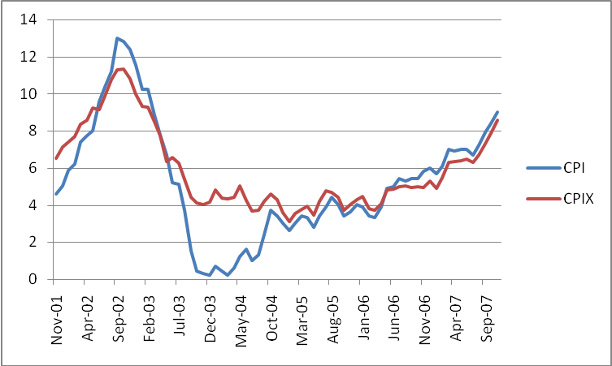
Figure 1. CPI and CPIX

Findings on frequency of price changes

Aggregate frequency of price changes, price increases and price decreases
With regard to the unweighted frequency of price changes, the headline finding of the study of unit level consumer prices over the period 2001m12 to 2007m12, is that an average of 16,8% of prices change each month.
It is interesting to note that over the 73 month period under consideration there was a significant degree of differentiation in the frequency of price changes with the highest frequency of price changes occurring in 2003m6 at 23,9% and the lowest frequency of price changes occurring in 2004m12 at 11,6%. Figure 2 broadly indicates an initial downward trend in the frequency of price changes, followed by an upward trend in the frequency of price changes from the end of 2005. As expected, such shifts in the frequency of price changes broadly follow the increases and decreases in the rate of inflation, with higher frequencies of price changes being associated with higher inflation rates and reduced frequencies of price changes being associated with lower inflation rates.

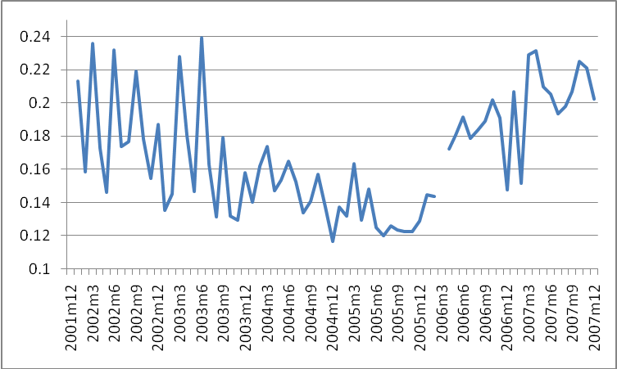
Figure 2. Frequency of price changes (proportion of prices changing per month). Price increases occurred with an average monthly frequency of 10,8% and price decreases with a frequency of 6,0%. This indicates a significant degree of asymmetry in price setting in favour of price increases over price decreases.

Until mid-2005, there was a downward trend in the frequency of price increases, followed by an increasing frequency of price increases associated with increasing inflationary pressures in the economy during 2006 and 2007 (see Fig.3).

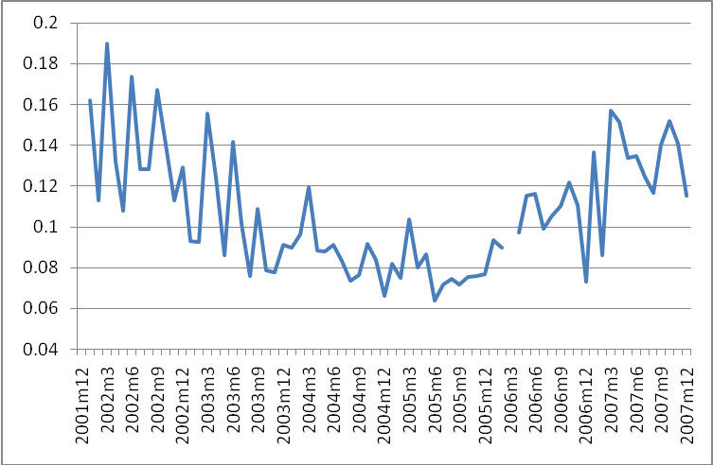
Figure 3. Frequency of price increases (proportion of prices increasing per month)
The month with the highest recorded frequency of price increases was 2002m3 with 19,0% of prices increasing in that month (linked with post currency depreciation inflationary pressures) and the month with lowest frequency of price increases was 2005m6 with 6,3% of prices increasing in that month. Shifts in the frequency of price increases broadly follow the increases and decreases in the rate of inflation, with higher frequencies of price increases being associated with higher inflation rates and reduced frequencies of price increases being associated with lower inflation rates.
With regard to the frequency of price decreases, there is broadly an upward trend over the entire period, with a sharp peak during the slowdown in inflation during mid 2003. Fig. 4 shows that the monthly frequency of price decreases has tended to increase with the highest frequency of price decreases recorded in 2003m6 (9,7%) and the lowest frequency of price decreases in 2002 m10 (3,8%). Shifts in the frequency of price decreases broadly follow an inverse relationship with changes in the rate of inflation, with higher frequencies in price decreases being associated with lower inflation rates and reduced frequencies in price decreases being associated with higher inflation rates. Although this relationship appears to break down in 2006 and 2007 where the frequency of price decreases rises even in the context of rising inflation.

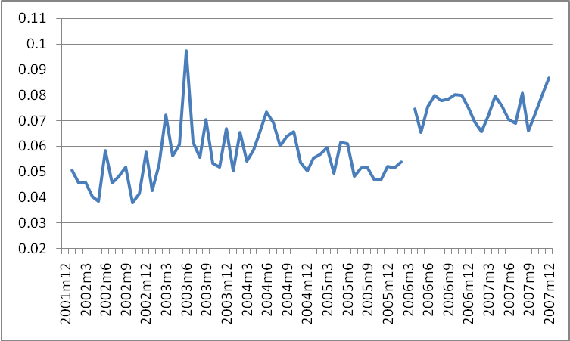
Figure 4. Frequency of price decreases (proportion of prices decreasing per month)

Alternative weighting procedures
The above findings are not weighted, but offer a description of the frequency of price changes for the data set as a whole and for the various product categories in the data set. The weighting of various product categories in the data set is not aligned to the weightings given to such product categories in the construction of the CPI and the CPIX, which in turn is based on surveys of household consumption patterns.
Re-weighting of the data based on the various product category weights underlying the CPI and CPIX during the period under review assists in offering alternative findings for pricing conduct which more closely reflects the proportional significance of various product categories in the wider economy. Such measures would be useful in estimating aggregate pricing conduct. Although the sample contains a large proportion of food price data, which experiences relatively high frequency price adjustments, the re-weighting results in an increased aggregate frequency of price adjustments since the weighting of other product categories with high frequencies of price changes, transport and other goods and services, increases with re-weighting. The aggregate frequency of price changes is 17,1% for both the CPI and CPIX weightings. Both of these estimates are larger than the estimate for the aggregate frequency of price change in unweighted sample of 16,8% due mainly to the increased weighting of transport and other goods and services.
There are equivalent changes for the re-weighted frequencies of price increase and price decreases. The frequency of price increases based on both the CPI and CPIX weightings is 11,1%. The frequency of price decreases for both is 6,0%, a similar finding as for the unweighted sample.

Table 2. Frequency of price changes with alternative weightings
 | Unweighted | CPI weighted | CPIX weighted
Frequency of price change | 16.8 | 17.1 | 17.1
Frequency of price increase | 10.8 | 11.1 | 11.1
Frequency of price decrease | 6.0 | 6.0 | 6.0

Comparison between goods and services
Well over 90% of price records are classified as goods rather than services and as a result there is a close similarity between the findings for pricing conduct for goods and findings for the aggregate data. Table 3 indicates that the prices of services generally change less frequently than the prices of goods. However, services prices increase more frequently than goods prices but decrease less frequently than goods prices.

Table 3. Average frequency of price changes for goods and services
 | Aggregate | Goods | Services
Frequency of price change | 16,8% | 17,0% | 14,9%
Frequency of price increase | 10,8% | 10,8% | 11,4%
Frequency of price decrease | 6,0% | 6,1% | 3,5%

Comparison of frequency of price changes of different product categories
The findings on the frequency of price changes by product category show that there is significant heterogeneity in pricing conduct for different product categories. Table 4 shows, by product category, the average frequency of price changes, the average frequency of price increase and the average frequency of price decreases.

Table 4. Average Frequency of price changes by Product Categories
Product Category | Frequency of Price Change | Frequency of Price Increase | Frequency of Price Decrease
FOOD | 20.5% | 13.1% | 7.5%
NON ALCOHOLIC BEVERAGES | 13.1% | 9.2% | 3.8%
ALCOHOLIC BEVERAGES | 12.5% | 9.7% | 2.9%
CIGARETTES TOBACCO AND CIGARS | 17.8% | 15.9% | 1.9%
CLOTHING | 8.8% | 5.0% | 3.8%
FOOTWEAR | 7.1% | 3.3% | 3.8%
FUEL AND POWER | 14.7% | 10.5% | 4.2%
FURNITURE AND EQUIPMENT | 12.0% | 7.4% | 4.6%
HOUSEHOLD OPERATION | 14.7% | 9.9% | 4.8%
MEDICAL CARE & HEALTH EXPENSES | 17.2% | 10.6% | 6.6%
TRANSPORT | 19.3% | 12.2% | 7.1%
COMMUNICATION | 6.7% | 5.5% | 1.2%
RECREATION AND ENTERTAINMENT | 13.8% | 7.5% | 6.3%
READING MATTER | 13.6% | 12.1% | 1.5%
PERSONAL CARE | 12.3% | 8.1% | 4.2%
OTHER GOODS AND SERVICES | 25.2% | 17.6% | 7.6%

For all products categories, except for footwear, the frequency of price increases is greater than the frequency of price decreases. These results are outlined graphically in Fig.5.
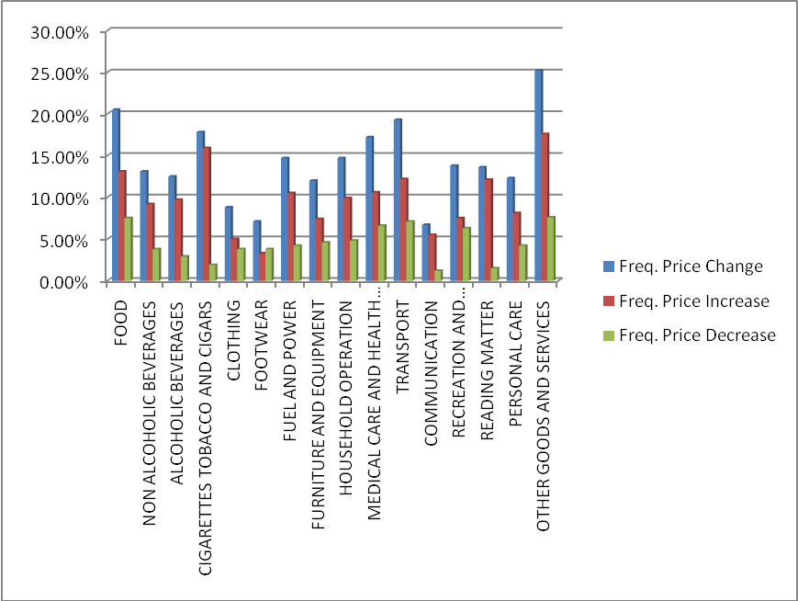
Figure 5. Average Frequency of price changes by Product Categories

Analysis of frequency of price changes by product category
The Table below lists product categories from those with the least frequently changed prices, to those with the most frequently changed prices.

Table 5. Frequency of Price Changes (ascending)
COMMUNICATION | 6.7%
FOOTWEAR | 7.1%
CLOTHING | 8.8%
FURNITURE AND EQUIPMENT | 12.0%
PERSONAL CARE | 12.3%
ALCOHOLIC BEVERAGES | 12.5%
NON ALCOHOLIC BEVERAGES | 13.1%
READING MATTER | 13.6%
RECREATION AND ENTERTAINMENT | 13.8%
HOUSEHOLD OPERATION | 14.7%
FUEL AND POWER | 14.7%
MEDICAL CARE AND HEALTH EXPENSES | 17.2%
CIGARETTES TOBACCO AND CIGARS | 17.8%
TRANSPORT | 19.3%
FOOD | 20.5%
OTHER GOODS AND SERVICES | 25.2%

Communication (6,7%), footwear (7,1%) and clothing (8,8%) prices change at relatively low frequency and are thus relatively sticky. Prices of other goods and services (25,2%), food (20,5%), transport (19,3%), cigarettes, tobacco and cigars (17,8%) and medical care and health expenses (17,2%) all change relatively frequently.

Analysis of frequency of price increases by product category
The most frequent price increases have occurred in housing (46,3%), other goods and services (17,6%) and cigarettes, tobacco and cigars (15,9%). The least frequent price increases occurred in footwear (3,3%), clothing (5,0%) and communication (5,5%).

Table 6. Frequency of price increases (ascending)
FOOTWEAR | 3.3%
CLOTHING | 5.0%
COMMUNICATION | 5.5%
FURNITURE AND EQUIPMENT | 7.4%
RECREATION AND ENTERTAINMENT | 7.5%
PERSONAL CARE | 8.1%
NON ALCOHOLIC BEVERAGES | 9.2%
ALCOHOLIC BEVERAGES | 9.7%
HOUSEHOLD OPERATION | 9.9%
FUEL AND POWER | 10.5%
MEDICAL CARE AND HEALTH EXPENSES | 10.6%
READING MATTER | 12.1%
TRANSPORT | 12.2%
FOOD | 13.1%
CIGARETTES TOBACCO AND CIGARS | 15.9%
OTHER GOODS AND SERVICES | 17.6%

Analysis of frequency of price decreases by product category
The most frequent price decreases have been in housing (9,8%), other goods and services (7,6%) and food (7,5%). The least frequent price decreases have been communication (1,2%), reading matter (1,5%) and cigarettes tobacco and cigars (1,9%).

Table 7. Frequency of price decreases (ascending)
COMMUNICATION | 1.2%
READING MATTER | 1.5%
CIGARETTES TOBACCO AND CIGARS | 1.9%
ALCOHOLIC BEVERAGES | 2.9%
CLOTHING | 3.8%
FOOTWEAR | 3.8%
NON ALCOHOLIC BEVERAGES | 3.8%
FUEL AND POWER | 4.2%
PERSONAL CARE | 4.2%
FURNITURE AND EQUIPMENT | 4.6%
HOUSEHOLD OPERATION | 4.8%
RECREATION AND ENTERTAINMENT | 6.3%
MEDICAL CARE AND HEALTH EXPENSES | 6.6%
TRANSPORT | 7.1%
FOOD | 7.5%
OTHER GOODS AND SERVICES | 7.6%

Findings on magnitudes of price changes

Aggregate magnitude of price changes, price increases and price decreases
With regard to the magnitude of price changes, the headline findings for the monthly data over the period 2001m12 to 2007m12, is that, conditional on the occurrence of a price change, the unweighted average absolute value magnitude of price changes was 13,1%. For those prices that rose, the average magnitude of price increases was 12,1%. For those prices that declined, the average magnitude of price decreases was -14,9%. The comparative medians were: an 8,7% magnitude of price changes, an 8,2% magnitude of price increases, and a -10,1% magnitude of price decreases. These median values are lower than the means since they limit the impact of extreme price increases and decreases.
It should be noted that, such findings record the monthly average size of price changes of those prices that did change in the period. This is distinct from the more familiar inflation-type measure of the monthly average size of price change, taking into account a weighted combination of all recorded prices, that is, including both those prices that have changed and those prices that have not changed.
Over the period the maximum overall average absolute value size of price change (including both prices that increased and decreased) was 14,7% in 2005m6 and the minimum overall average size of price change was 11,0% in 2007m10. The month with the highest median price change of 10,5% was 2002m6, and with the lowest median price change of 7,7% was 2006m6.

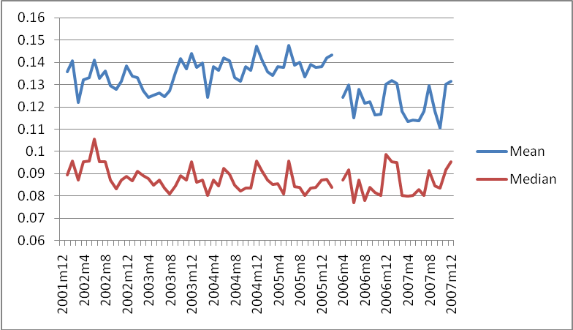
Figure 6. Magnitude of price changes (absolute value)

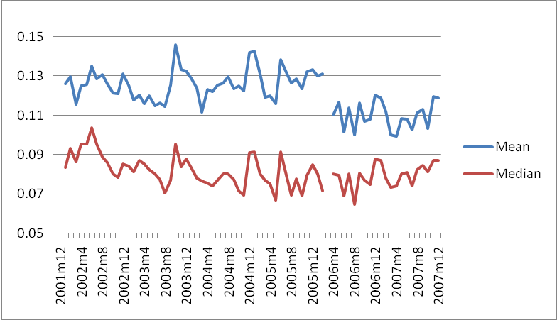
Figure 7. Magnitude of price increases

The month with the largest average price increase was 2003m10 at 14,6% and the month with the smallest average price increase was 2007m4 at 9,9%. Monthly median price increases were considerably lower peaking in 2002m6 at 10,4%, with a low median of 6,5% in 2006m8.
The month with the largest average price decrease was 2005m5 at -16,8% and the month with the smallest average price decrease was 2007m5 at -12,4%. Monthly median price decreases were largest in 2006m5 at -12,3% and smallest in 2003m10 at -8,0%.
In absolute value terms, the magnitude of price decreases is greater than the magnitude of price increases, although price increases generally occur more frequently.

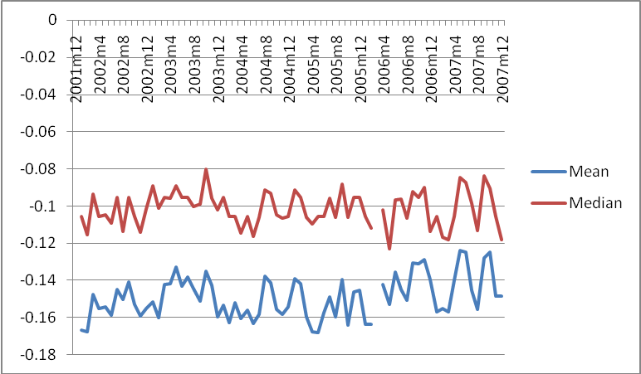
Figure 8. Magnitude of Price Decreases

Alternative weighting procedures
The above findings for the magnitudes of price changes are not weighted, but offer a description of the magnitude of price changes for the data set as a whole and for the various product categories in the data set. Re-weighting of the data based on the various product category weights underlying the CPI and CPIX during the period under review assists in offering alternative findings for pricing conduct which more closely reflects the proportional significance of various product categories in the wider economy.
As per Table 8, using CPI weightings, the aggregate absolute value magnitude of price increases is lower at 11,4%, as compared to the unweighted absolute magnitude of price changes of 13,1%. The CPIX weighted absolute value magnitude of price changes is 11,5%.

Table 8. Magnitude of price changes with alternative weightings
 | Unweighted | CPI weighted | CPIX weighted
Magnitude of price change | 13.1 | 11.4 | 11.5
Magnitude of price increase | 12.1 | 10.7 | 10.9
Magnitude of price decrease | -14.9 | -12.3 | -12.5

The consequence of the reweighting is a muting of the price change magnitudes, as the weights shift from high to lower price change magnitude product categories. The weighting on the food category, which has relatively high magnitudes of price changes, is reduced, and the weighting on transport, which has relatively lower magnitudes of price changes, is increased. The aggregate magnitude of price increase falls from 12,1% for the unweighted data to 10,7% for the CPI weighted data and 10,9% for the CPIX weighted data. The aggregate magnitude for price decreases falls from -14,9% for the unweighted data to -12,3% for the CPI weighted data and -12,5% for the CPIX weighted data.

Comparison of the magnitude of price changes between goods and services

The magnitude of price changes is significantly greater for goods than for services. The average size of price increases and price decreases is much larger for goods than for services, as services experience more moderate price changes. The average size of price increases for goods is 12,3%, whereas for services it is 5,7%. The average size of price decreases for goods is -15,0%, whereas for services it is -4,7%. Due to the large proportion of goods prices in the sample, the size of goods price changes are broadly similar to the aggregate size of price increases, which average 12,1% per month and the size of price decreases which average -14,9% per month.

Analyses of magnitude of price changes by product category
The findings on the size of price changes by product category are outlined in Table 10. The Table shows the overall average absolute value size of price changes where prices changed, the average size of price increases where prices rose and the average size of price decreases where prices declined. There is considerable heterogeneity in the magnitude of price changes across various products.

Analysis of magnitude of price increases by product category
The largest average price increases have been in footwear (18,9%), recreation and entertainment (14,4%), furniture and equipment (13,8%) and food (13,3%). The smallest average price increases have been in communication (1,8%), and other goods and services (3,0%).

Table 9. Average size of price changes for goods and services
 | Aggregate | Goods | Services
Absolute size of price changes | 13,1% | 13,2% | 5,5%
Size of price increases | 12,1% | 12,3% | 5,7%
Size of price decreases | -14,9% | -15,0% | -4,7%

Table 10. Magnitude of price changes
 | Magnitude of Change | Magnitude of Increases | Magnitude of Decreases
FOOD | 14.2% | 13.3% | -15.8%
NON ALCOHOLIC BEVERAGES | 11.5% | 10.8% | -13.2%
ALCOHOLIC BEVERAGES | 8.2% | 8.2% | -8.2%
CIGARETTES TOBACCO AND CIGARS | 5.7% | 5.7% | -5.9%
CLOTHING | 17.8% | 12.6% | -24.7%
FOOTWEAR | 24.1% | 18.9% | -28.5%
FUEL AND POWER | 10.6% | 10.8% | -10.3%
FURNITURE AND EQUIPMENT | 15.2% | 13.8% | -17.5%
HOUSEHOLD OPERATION | 11.8% | 11.3% | -12.7%
MEDICAL CARE AND HEALTH EXPENSES | 10.1% | 10.5% | -9.5%
TRANSPORT | 8.7% | 8.8% | -8.5%
COMMUNICATION | 1.7% | 1.8% | -1.3%
RECREATION AND ENTERTAINMENT | 15.8% | 14.4% | -17.4%
READING MATTER | 7.6% | 6.1% | -20.0%
PERSONAL CARE | 12.2% | 11.9% | -12.9%
OTHER GOODS AND SERVICES | 3.5% | 3.0% | -4.4%

Table 11. Mean Magnitude of Price Increases (descending)
FOOTWEAR | 18.9%
RECREATION AND ENTERTAINMENT | 14.4%
FURNITURE AND EQUIPMENT | 13.8%
FOOD | 13.3%
CLOTHING | 12.6%
PERSONAL CARE | 11.9%
HOUSEHOLD OPERATION | 11.3%
FUEL AND POWER | 10.8%
NON ALCOHOLIC BEVERAGES | 10.8%
MEDICAL CARE AND HEALTH EXPENSES | 10.5%
TRANSPORT | 8.8%
ALCOHOLIC BEVERAGES | 8.2%
READING MATTER | 6.1%
CIGARETTES TOBACCO AND CIGARS | 5.7%
OTHER GOODS AND SERVICES | 3.0%
COMMUNICATION | 1.8%

Analysis of magnitude of price decreases by product category
The largest average price decreases have been for footwear (-28,5%), clothing (-24,7%), and reading matter (-20,0%). The smallest average price decreases have been in communication (-1,3%), and other goods and services (-4,4%).

Table 12. Mean Magnitude of Price Decreases (absolute value descending)
FOOTWEAR | -28.5%
CLOTHING | -24.7%
READING MATTER | -20.0%
FURNITURE AND EQUIPMENT | -17.5%
RECREATION AND ENTERTAINMENT | -17.4%
FOOD | -15.8%
NON ALCOHOLIC BEVERAGES | -13.2%
PERSONAL CARE | -12.9%
HOUSEHOLD OPERATION | -12.7%
FUEL AND POWER | -10.3%
MEDICAL CARE AND HEALTH EXPENSES | -9.5%
TRANSPORT | -8.5%
ALCOHOLIC BEVERAGES | -8.2%
CIGARETTES TOBACCO AND CIGARS | -5.9%
OTHER GOODS AND SERVICES | -4.4%
COMMUNICATION | -1.3%

Duration of Prices

Based on the assumptions of stationarity and homogeneity of price change behaviour, it has been shown that the inverse of the frequency of the price changes converges, in a large sample, to the mean duration of prices, that is: $T^{F}=\frac{1}{F}$ , where $T^{F}$represents the average duration of price spells and $F$ represents the frequency of price changes. Where the assumptions of stationarity and homogeneity of pricing conduct do not hold as is the case in this study, it is necessary directly to compute price durations.
Using the direct computation method outlined in Appendix A, it is found that the average duration of prices for uncensored price spells is 3,9 months at the aggregate level. But due to the fact that there is a break in the data, which results in a situation where it is not possible to track pricing at specific stores, the direct computation of price durations means a sharp decrease in durations at the beginning of 2006. The effect of the break is to bring down the average duration of prices over the full period. The average duration of prices for uncensored price spells for the period before the break in the data is 4,2 months. Even during this reduced period the average duration of prices increases over time, as longer data periods lend themselves to the measurement of longer price durations.
As per Table 13, over the full period alcoholic beverages (6,0 months), footwear (5,4 months), non-alcoholic beverages (4,8 months) and personal care items (4,8 months) have the longest unweighted and uncensored average price durations, whereas other goods and services (1,7 months) have the shortest such average price durations.

Table 13. Mean duration of prices by product category (in months)
ALCOHOLIC BEVERAGES | 6.0
FOOTWEAR | 5.4
NON ALCOHOLIC BEVERAGES | 4.8
PERSONAL CARE | 4.8
FURNITURE AND EQUIPMENT | 4.6
MEDICAL CARE AND HEALTH EXPENSES | 4.6
COMMUNICATION | 4.6
RECREATION AND ENTERTAINMENT | 4.6
CIGARETTES TOBACCO AND CIGARS | 4.5
FUEL AND POWER | 4.4
HOUSEHOLD OPERATION | 4.4
CLOTHING | 3.9
TRANSPORT | 3.7
FOOD | 3.5
READING MATTER | 3.4
OTHER GOODS AND SERVICES | 1.7

In order to compensate for the fact that there is a high concentration of price spells with short durations, Alvarez et al., (2004) adopt alternative weighting procedures. These procedures had the effect of lifting the average unweighted price duration from 4,9 months to 11,4 months (where price durations were weighted by the CPI weight of the subclass) and to 14,7 months (where price durations are averaged within the same trajectory) for the Spanish economy over the period 1993 to 2001. For the South African data over the entire period under review, re-weighting by CPI and CPIX, as done for the frequency and magnitude of price changes, increases the average duration to 4 months (Table 14).
Table 14. Duration of price with alternative weightings
 | Unweighted | CPI weighted | CPIX weighted
Duration of prices | 3.9 | 4.0 | 4.0

Comparative Analysis

A brief summary of similar studies of unit level price data enables a comparison with the findings for South Africa.

Table 15. Comparison of findings of CPI micro data Analysis
 | Frequency of price change | Frequency of price increase | Frequency of price decrease | Average size of price increase | Average size of price decrease
South Africa (2001-2007) | 17.1 | 11.1 | 6.0 | 10.9 | -12.5
Euro Area (1996-2001) | 15.1 | 8.3 | 5.9 | 8.2 | -10
USA (1998-2003) | 24.8 | 16.1 | 13.2 | 12.7 | -14.1
Spain (1993-2001) | 15 | 9 | 6 | 8.2 | -10.3
France (1994-2003) | 18.9 | 9.7 | 6.5 | 12.5 | -10
Brazil (1996-2006) | 37 | 22.2 | 19 | 16 | -12.6
Sierra Leone (1998-2003) | 51 | 20.1 | 21.4

By way of comparison, it is possible to comment at the aggregate level that, with regard to the frequency of price changes, that the finding for South Africa 17,1% using CPIX weighted data, would appear to be broadly similar to findings for Spain (15%), the Euro Area (15,1%) and France (18,9%). The United States economy would appear to have a significantly greater frequency of price changes (24,8%), including higher frequencies both of price increases and price decreases. Similarly, Brazil has experienced a significantly higher frequency of price changes (37%) than South Africa, and a higher frequency of price increases and price decreases.
The average magnitude of price increases in South Africa is 10,9%. This is larger than for the Euro Area (8,2%) and Spain (8,2%). In the United States the average size of price increases is 12,7%. The size of South Africa’s price increases is smaller than those of Brazil (16%), the United States (12,7%) and France (12,5%). The average size of price decreases in South Africa (-12,5%) is similar to the average size of price decreases in Brazil (-12,6%), is larger than for the Euro Area (-10%), France (-10%) and Spain (-10,3%) but smaller than for the United States (-14,1%).
Price setting conduct in South Africa bears little resemblance to high-inflation Sierra Leone where the frequency of price change averages 51% in the period between 1999 and 2003. In Sierra Leone’s case the frequency of price changes declined from 90% in 1999 to about 40% in 2003.

Extending the microdata research

An extension of the current research would be to analyse South Africa’s consumer price microdata in order to establish the extent of time-based or state-based pricing conduct in the South African economy over the period.
In order to understand the influence which various factors have on the frequency of price changes, the following regression model could be estimated, for frequencies of price changes (F), for frequencies of price increases (F+) and for frequencies of price decreases (F-), as well as for magnitudes of price changes (M), for magnitudes of price increases (M+) and for magnitudes of price decreases (M-):
$\text{Ft}=a+\sum_{i=1}^{\text{12}}{B+}κ\text{CPIt}+λ\text{REPOt}+σ\text{NERt}+εt$
Where:
Ft = frequency of price changes in a particular month t
a = constant term
$\sum_{i=1}^{\text{12}}{B=}$seasonal dummies
CPIt = year on year consumer price index in month t
REPOt = policy rate (repo rate) in month t
NERt = nominal exchange rate index in month t
ε = error term

This will allow for estimation of the relationship between pricing conduct and seasonal factors, as well as the relationship between pricing conduct and changes in the reported CPI inflation rates, changes in the repo rate and changes in the nominal effective exchange rate. In addition to real time effects, the analysis could include lagged effects.

Conclusion

This paper presents the first attempt to use unit level pricing data to describe pricing conduct in the South African economy. The results illustrate the heterogeneous nature of pricing behaviour and show the significant changes that have taken place in aggregate and disaggregated pricing conduct. This is significant as the period under review constitutes an important period after the introduction of an inflation targeting monetary policy framework in South Africa. This unique research is made possible by access to the underlying data collected by StatsSA for the calculation of the CPI.
This paper is part of a broader research effort into the implications of price setting behaviour for the conduct of monetary policy in South Africa. In future research, an analysis of factors influencing the frequency and size of price changes is proposed, including such factors as seasonality, the prevailing rate of inflation, preference for round prices, interest rate developments and exchange rate developments. It may then be possible to conduct an analysis of the extent to which price setting in the period can be shown to be state-dependant or time-dependant and to conduct a more detailed comparison of results for the South African economy with the results for other countries where similar micro level price data analyses have been undertaken.

Appendix A – Computation of price duration

Direct calculation of duration of price spells is coded in STATA as follows. The reason that ‘k’<=51 is due to the impact of the break in the data, where the unique store numbers become incomparable. This has the effect that the longest possible duration of any price spell may be over the period of the first data set of 51 months, rather than the 73 months over which the study is conducted.

gen change=price-l.price

gen changedummy=1 if change~=0 & change~=.
replace changedummy=0 if change==0

gen lagchangedummy=l.changedummy

gen changedate=edate2 if changedummy==1

gen lastchangedate=l.edate2 if l.changedummy==1

local k=2

while `k'<=51{

replace lastchangedate=l`k'.edate2 if lastchangedate==. & l`k'.changedummy==1
local k=`k'+1
}

format changedate lastchangedate %tm

gen duration=edate2-lastchangedate

gen duration_uncensored=changedate-lastchangedate

References

Altissimo, F., Ehrmann, M. and Smets, F. (2006) “Inflation Persistence and Price Setting Behaviour in the Euro Area”, European Central Bank, Occasional Paper Series No.46, June 2006.
Alvarez, L. and Hernando, I. (2006) “Price setting behaviour in Spain. Stylised facts using consumer price microdata”, Economic Modeling, 23, pp.699-716,
Alvarez, L., Burriel, P. and Hernando, I. (2005) “Price setting behaviour in Spain: evidence from micro PPI data”, European Central Bank Working Paper No. 522, 2005
Alvarez, L. and Hernando, I. (2005) “The Price setting behaviour of Spanish Firms: Evidence from Survey Data”, European Central Bank Working Paper No.538, October 2005
Alvarez, L., Dhyne, E., Hoeberichts, M., Kwapil, C., Le Bihan, H., Lunnemann, P., Martins, F., Sabbatini, R., Stahl, H., Vermeulen, P. and Vilmunen, J. (2006) “Sticky Prices in the Euro Area: A summary of new micro evidence”, Journal of the European Economic Association, 4 (2-3), pp.575-584, 2006
Baharad E and Benjamin E, “Price Rigidity and Price Dispersion: Evidence from Microdata”, August 2003
Baudry, L., Le Bihan, H., Sevestre, P. and Tarrieu, S. (2007) “What do thirteen million price records have to say about consumer price rigidity?”, Oxford Bulletin of Economics and Statistics, 69(2), pp. 139-183, 2007
Bils, M. and Klenow, P. (2004) “Some evidence on the importance of sticky prices”, Journal of Political Economy, 112, pp.947-985, 2004
Coricelli, F. and Horvath, R. (2008) “Price setting and market structure: an empirical analysis of microdata”, Institute of Economic Studies, Charles University in Prague, IES Working Paper 23, 2008
Dhyne, E., Alvarez, L., Le Bihan, H., Veronese, G. Dias, D., Hoffman, J., Jonker, N., Lunnermann, P., Rumler, F.,\ and Vilmunen J, (2005) “Price setting in the Euro Area: Some stylised facts from individual consumer price data” ECB Working Paper, No.524, 2005
Dias, D. Marques, C. and Silva, J. (2005) “Time or state dependent price setting rules – Evidence from Portuguese micro data”, European Central Bank, Working Paper Series, No. 511, August 2005
Gali, J. (2008) “Monetary Policy, Inflation, and the Business Cycle – An introduction to the New Keynesian Framework”, Princeton University Press
Gouvea, S. (2007) “Price Rigidity in Brazil: Evidence from CPI Micro Data”, Banco Central Do Brasil, Working Paper Series 143, September 2007
Klenow, P. and Kryvstov, O. (2005) “State-dependent or time-dependent pricing: Does if Matter for Recent US Inflation?”, NBER Working Paper No. 11043, January 2005
Kovanen, A. (2006) “Why do prices in Sierra Leone Change So Often? A Case Study Using Micro Level Price Data”, IMF Working Paper WP/06/53

Thanks are owed to Dr Greg Farrell of the South African Reserve Bank for helpful discussions and also to Patrick Kelly of Statistics South Africa (StatsSA) for the provision of the data.
*School of Economic and Business Sciences, University of the Witwatersrand, Johannesburg, South Africa, Kenneth.Creamer@wits.ac.za
**African Micro-Economic Research Umbrella, School of Economic and Business Sciences, University of the Witwatersrand, Johannesburg, South Africa Neil.Rankin@wits.ac.za
The model also provides for analysis of the optimal conduct of monetary policy in the context of varying degrees of intrinsic inflation persistence (indicated by γ in the model). Intrinsic inflation persistence increases with the increase in the degree of backward-looking indexation with reference to previous inflation in price setting (associated with rising γ in the model).
The frequency of price changes (increases or decreases) is defined as the percentage of prices that change (increase or decrease) as a proportion of all price records, in the aggregate or for a specific product category, in a particular month. The magnitude of price changes is defined as the absolute value of the one period difference, month on month, of the natural log of prices. The magnitude of price increases is the differenced natural log of price increases that are greater than zero and the magnitude of price decreases is the differenced natural log of price decreases. The duration of prices is a measure of uncensored periods during which prices do not change. Price duration is measured in months.
In the first data set capture codes 0, 1, 4, 5 and 6 were used and in the second data set, item status codes included were 20, 21, 23 and 24. Excluded were such capture codes as those for out of stock goods and incomparable good s due to changes in quality.
Given that the study is based on monthly price change frequencies and magnitudes, prices collected quarterly, annually, or at other non-monthly intervals have been excluded from the data to be analysed. This is also the approach adopted in other microdata studies (see Alvarez et al., 2004). Housing prices were excluded due the fact that certain housing sub-sector price information – including the prices of rental stock of housing, flats and townhouses – is based on a frequently updated price index rather than on actual pricing conduct. Hence, there is a tendency for small, but frequent changes in price. This is as a result of a practice by the statistical authorities during the period under review, but subsequently discontinued, that any observed price change over a quarter was distributed over the three months of the following quarter.
From 2009 the basket of goods and services in the CPI is to be reduced to fewer than 400 goods. From 2009 the Classification of Individual Consumption by Purpose (COICOP) system is to be introduced which will result in some changes to the categorisation of the CPI basket. At the same time, new weights for the goods and services in the CPI are also to be introduced based mainly on the consumptions patterns found in the Income and Expenditure Survey of 2005/2006.
In addition to have a higher frequency of price decreases as compared to price increases. Footwear is the product category with the highest and the lowest magnitude of price changes.
Items covered in Other Goods and Services include: watches, sunglasses, envelopes, pens and pencils, professional fees, legal fees, cost of funeral, insurance, take away meals, contributions to pension funds, swimming pool equipment and repairs, lobola/dowry payments, religious and traditional ceremonies and fines.
In symmetric distributions the mean and the median are the same. However, the distributions of the variables of interest in this paper – frequency, magnitude and duration – are unlikely to be symmetric. These variables should all have distributions where most of the observations are concentrated around or towards zero. They will thus be skewed towards values larger in absolute magnitude and thus, even in a large sample, the mean will be larger in absolute value than the median.
See Alvarez et al., 2004
See Alvarez et al., 2004
Data for South Africa is based on results of the current study. Data for Euro Area is from Dhyne et al., (2005) and for the United States is from Bils and Klenow (2004) and from Klenow et al., (2005). Data on Spain is from Alvarez et al., (2004). Data on France is from Baudry (2004). Data on Brazil is from Gouvea (2007). Data on Sierra Leone is from Kovanen (2006). Due to the adoption to differing methodologies in the various studies, not all results are strictly equivalent, yet the results allow for general comparisons of pricing conduct in a number of economies.

