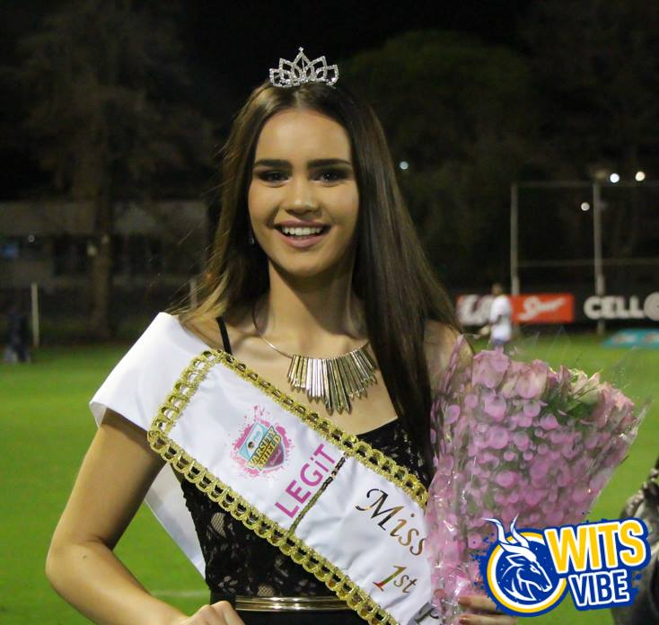

1. **NAME and SURNAME**

1. **CONTACT DETAILS**

Contact Number:

Email Address:

1. **RESIDENCE** (If applicable)
2. **CAREER AMBITION**
3. **CURRENT YEAR OF STUDY in 2017**

1. **INTERESTS, TALENTS & HOBBIES**
2. **REASON FOR ENTERING MISS WITS VARSITY CUP**
3. **FAVOURITE RUGBY PLAYER?**

.

***Remember to attach a full length photo.***